Triston Luzanta

Matlab Project 2

ECE 2523

|  |  |  |  |  |
| --- | --- | --- | --- | --- |
| Machine | P[A|Bi] | P[Bi] | P[Bi|A] | Resistors/Hour |
| B1 (after upgrade) | 0.9008 | 0.25 | 0.28 | 4000 |
| B1 (before upgrade) | 0.8 | 0.3 | 0.31 | 3000 |
| B2 (after upgrade) | 0.7085 | 0.25 | 0.2202 | 4000 |
| B2 (before upgrade) | 0.9 | 0.4 | 0.46 | 4000 |
| B3 (after upgrade) | 0.8038 | 0.5 | 0.4997 | 8000 |
| B3 (before upgrade) | 0.6 | 0.3 | 0.23 | 3000 |

To figure out how to get the probability of the total acceptable resistors of the entire factory together, we use the law of total probability. These values were calculated from our Matlab Functions.

P[A] = P[A|B1] * P[B1] + P[A|B2] * P[B2] + P[A|B3] * P[B3]

P[A] = (0.9008) * (0.25) + (0.7085) * (0.25) + (0.8038) * (0.50) = 0.804225

If all the resistors were mixed together randomly in a box, the probability of drawing an acceptable resistor from the box would be 0.804225 or 80.4225% chance.

To get P[Bi|A], we used Bayes Theorem.

Where, P[Bi|A] = $\frac{P[A|Bi]}{P[A] }$* P[Bi]

Ex. P[B1|A] = * 0.25 = 0.28

We then plug in the nominal values for each resistor machine into this equation to figure out the probability of withdrawing an acceptable resistor from the corresponding resistor machine out of the entire factory.

Appendix:

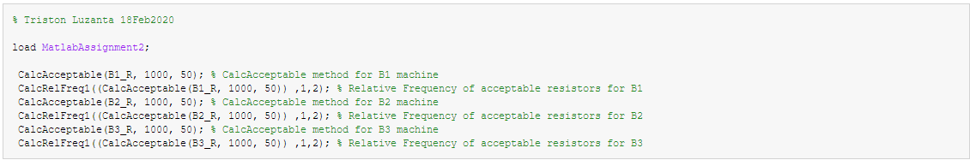Main File:

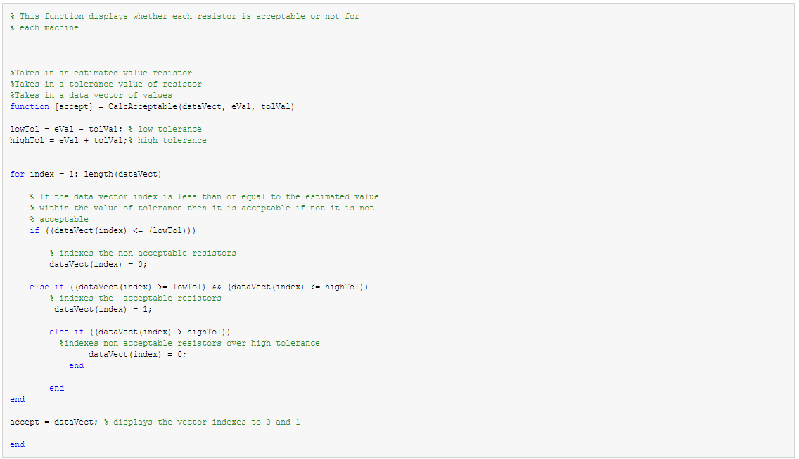CalcAcceptable Fn:

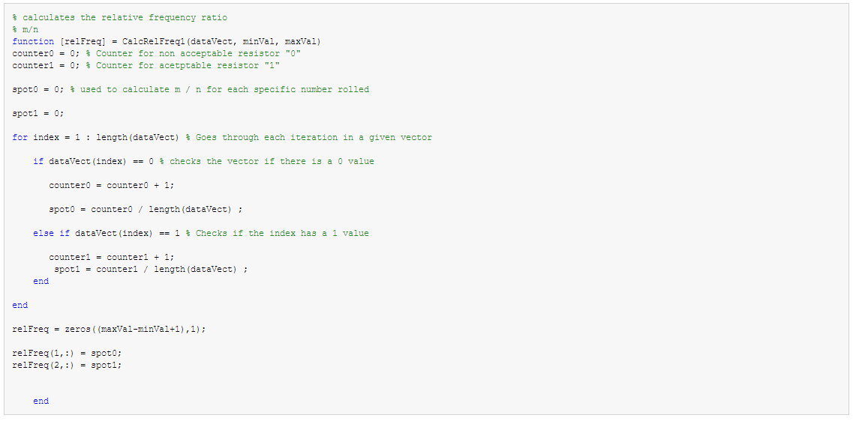CalcFreq1 Fn: